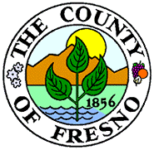
County of Fresno

DEPARTMENT OF BEHAVIORAL HEALTH
SUSAN L. HOLT
DIRECTOR OF BEHAVIORAL HEALTH
PUBLIC GUARDIAN

Notice of Significant Change

Effective Date: January 1, 2025

The Fresno County Department of Behavioral Health (FCDBH) will release an updated Behavioral Health Member Handbook.

Key Update:

The handbook will now include information on Justice-Involved Reentry Services.

How to Access the Updated Handbook

Starting January 1, 2025, the updated handbook will be available in English, Spanish, and Hmong. You can access it:

- By requesting a copy from your provider
- By downloading it from the FCDBH website: fresnocountyca.gov/Departments/Behavioral-Health/Care-Services/Programs-Services/Persons-Served-Provider-Downloads

Additional Support:

To request a printed copy, auxiliary aids, or alternative formats at no cost, contact the Fresno County 24/7 Access Line at 1-800-654-3937 (TTY: 711)

Issuance Date: December 2, 2024

